

**STAT 365**

**Survey Sampling Techniques**

**The Factors Influencing Voting Behavior in the 2023 Turkish Presidential Election**

*By*

*Mehmet Barış DURMUŞ - 2429017*

*Halil Ege EVRAN - 2218121*

*Alper Tunahan ÖZTÜRK - 2290856*

*Middle East Technical University*

*Department of Statistics*

January 2023

Ankara, Turkey

Table of Contents

Abstract 1

Introduction 1

Literature Review 2

Aim of the Research 3

Research Question 3

Survey Description 3

Methodology/Analysis 4

Results and Findings 11

Does the state of the nation's economy perception depend on student's income? 11

Is there any relationship between freedom of speech and Turkey citizens desire to apply to the EU? 13

Is there any effect of religion to the people's perspective against their civil rights? 15

Conclusion 16

References 17

## Abstract

The concept of democracy has been defined in a variety of ways, so there exist some differences on how it is perceived by societies. This study was conducted in the purpose of analyzing the factors that might be effective on the voting behavior of the METU students in the 2023 presidential election. A questionnaire which consists of 42 questions was used to gather data from 225 students, who were from different faculties, classes and age groups; and this survey was used as the source of this study. Non-parametric methods were applied such as Kruskal-Wallis test and Wilcoxon Rank Sum test due to survey data being non-normal and three research questions were answered. The gathered data was analyzed by using R Studio and Excel descriptive statistics.

## Introduction

Democracy is a concept that has different definitions, and it can be challenging to come to an agreement on it. Democracy, which is expressed as a form of policy based on the sovereignty of the society, is also defined as the public administration established with representatives elected through a free electoral system. According to these definitions, sovereignty is based on the majority of the people, that is, on the people, as a result of the people's decision on how to govern with their own will. There is no common view on the perception of democracy, which is defined in various ways and which is the form of administration of modern states. Although not all societies have the same point of view towards democracy, the shaping of society's perception of democracy is closely related to their cultural structures, religious beliefs, and lifestyles of individuals who make up that society. We are doing research on the factors that affect the voting behaviors of METU students in the 2023 Turkish presidential elections. The participants will be asked questions and the results will be taken into account.

## Literature Review

Elections are essential for countries because of their effect on the country's future. To be able to estimate the result of the elections, understanding voting behavior is crucial. Voting behavior is complicated since many rational or irrational factors can affect it. There are three different approaches to voting. These are sociological, psychological, and rational (economic) approaches (Kalander, 2005). The sociological approach is based on factors such as the group to which the voter belongs, socio-economic status, place of residence, and religion rather than the characteristics of the voter (Kalender, 2005). According to this model, which examines voter behavior from a sociological perspective, voters can be influenced by the behavior of their social groups. Primary or secondary social groups influence voters' decisions in forming their political loyalty (Visser, 1998: as cited in Duygu, 2017). According to the socio-psychological approach, also known as the Michigan school, voters have a bond of affection for a party based on the past. There is a kind of party identity, a loyalty that dates back to childhood (Çinko, 2006). Individuals feel an affinity to a particular party from an early age, first under the influence of their families and then their immediate environment, and this affinity strengthens over time and turns into loyalty and partisanship and continues throughout life. Therefore, these individuals are expected to vote mostly for the same party (Temizel, 2012). Another model is the "Rational Approach" theory developed by Downs in 1957. According to this approach, voters make decisions by considering their own interests and making a cost-benefit analysis, as in purchasing decisions. In other words, voters make decisions with the same approach when voting as they do when purchasing a product or service (Dean & Croft, 2009). In this approach, voters will make an evaluation among the parties and candidates that they know their own interests very well and that they believe will best serve these interests and will engage in voting behavior as a result of this evaluation. This research aims to discover factors that might be relevant to these three approaches.. The study investigates the voting behavior of Turkish residents who will vote in the 2023 elections. Approximately 63 million voters will vote in the general elections of 2023. Therefore, examining the factors that can affect voters' voting decisions will be a guide for especially political parties. The study contributes to foreign and domestic literature by examining the possible factors influencing the voting behavior of Turkish citizens.

## Aim of the Research

All societies do not have the same point of view towards democracy, the shaping of society's perception of democracy is closely related to their cultural structures, religious beliefs, and lifestyles of individuals who make up that society. We aim to analyze the factors that can be effective on the voting behavior of the METU students in the 2023 presidential election. By directing some specific questions to people who attend this survey, our purpose is to find out the most crucial factor on the voting behaviors of METU students. We are looking for answers if the Turkish university students has any factor that affects their voting behaviors.

## Research Question

* Does the state of the nation's economy perception depend on student's income?
* Is there any relationship between freedom of speech and Turkey citizens desire to apply to the EU?
* Is there any effect of religion to the people's perspective against their civil rights?

## Survey Description

The factors influencing voting behaviour in the 2023 Turkish presidential election survey has 42 questions. It involved asking questions about their demographic, freedom, equality, and economy structure. The survey was included, open-ended questions, and multiple-choice questions. It gathered both quantitative and qualitative data and was used to understand the students' voting behaviors in the 2023 Turkish presidential election. 225 METU students participated in the survey. The response rate of the survey is 26%.

## Methodology/Analysis

In this section, there is an EDA of the survey. It consists of bar graphs and pie charts. The graphs are prepared for the better understanding of survey data. From the graphs, one can understand what type of students attend the survey(Age, Gender, Education Level, Faculty…), what are their political opinions, what are the problems of Turkey and what they think about these problems, what they think the solution is and etc.

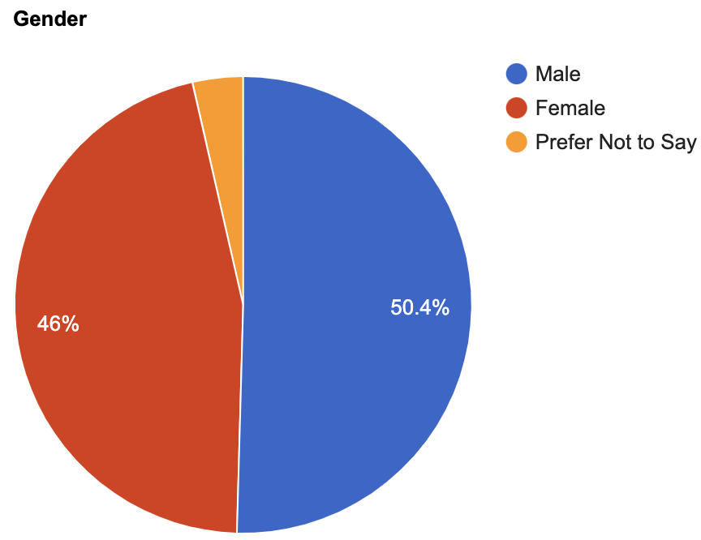

Figure

In this pie chart, it is seen that the survey is taken from both genders nearly the same. Also, there are students who do not want to give information about their genders.

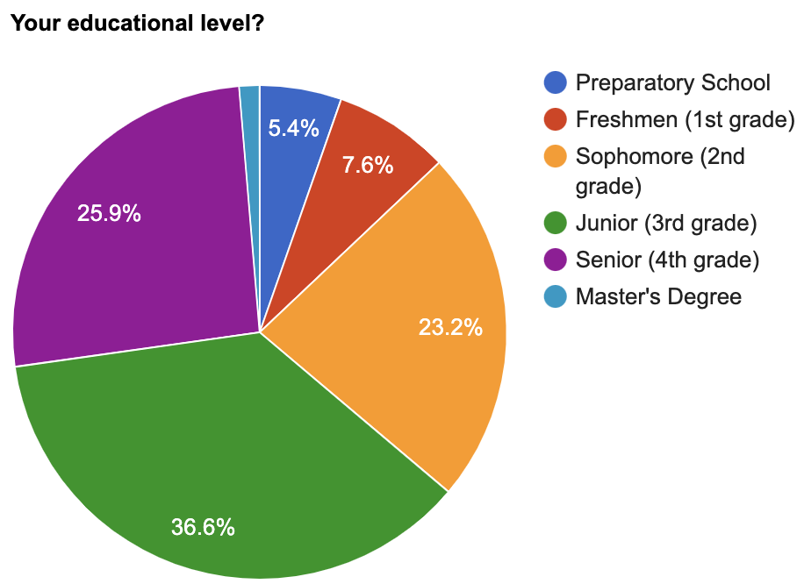The pie chart on the right shows the education level of METU students who fill this survey. It can be seen that the students in 3rd and 4th grades who attend the survey are more than the others education level.

Figure

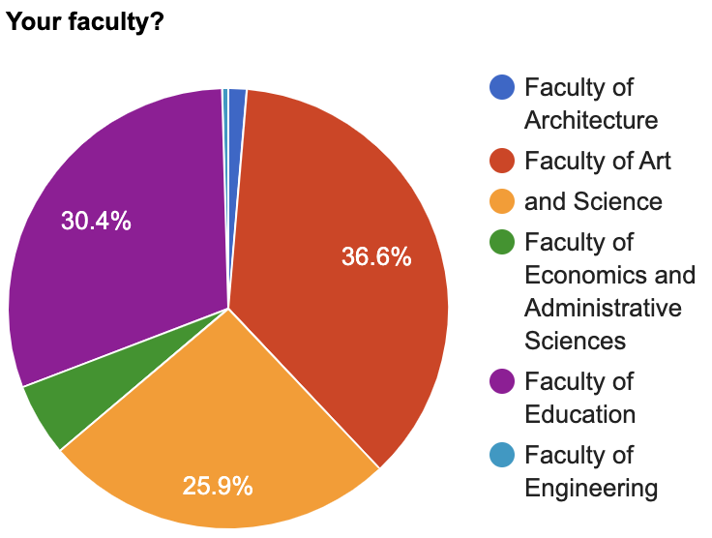

Figure

Now, this is another question`s pie chart which is about the faculties of survey attenders. In this pie chart, it can be shown the METU students who attend the survey faculties.

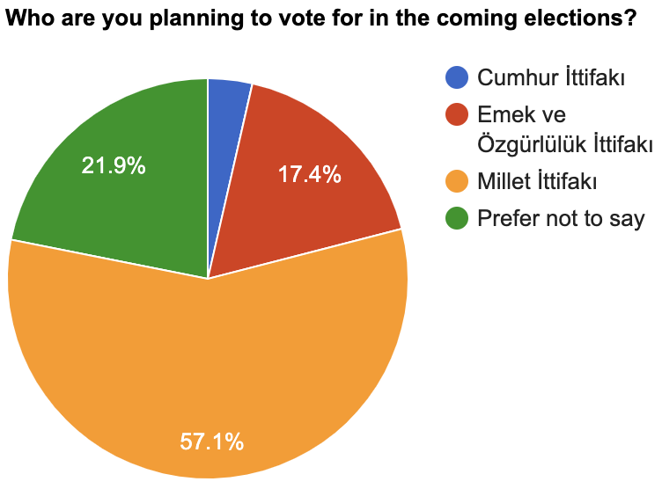The majority of the METU students who attend the survey are planning to vote for Millet Ittifaki. Even though it is not a certain vote number, it can give some sort of idea.

Figure

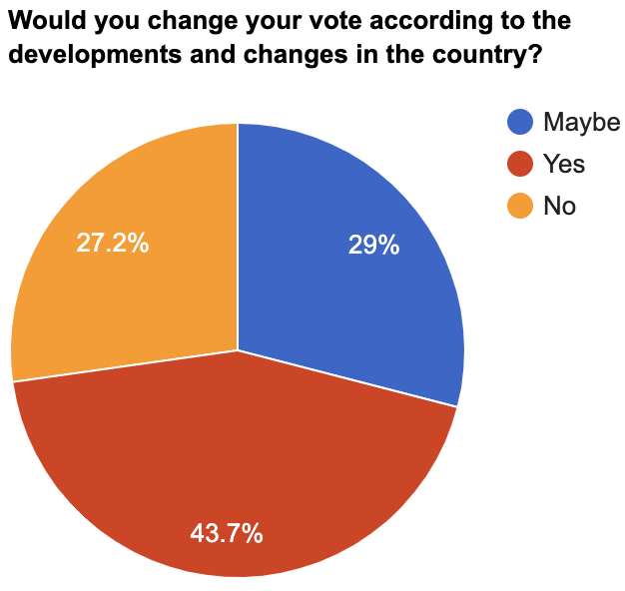In this pie chart, it can be said that METU students can change their vote according to the developments and changes in the country.

Figure

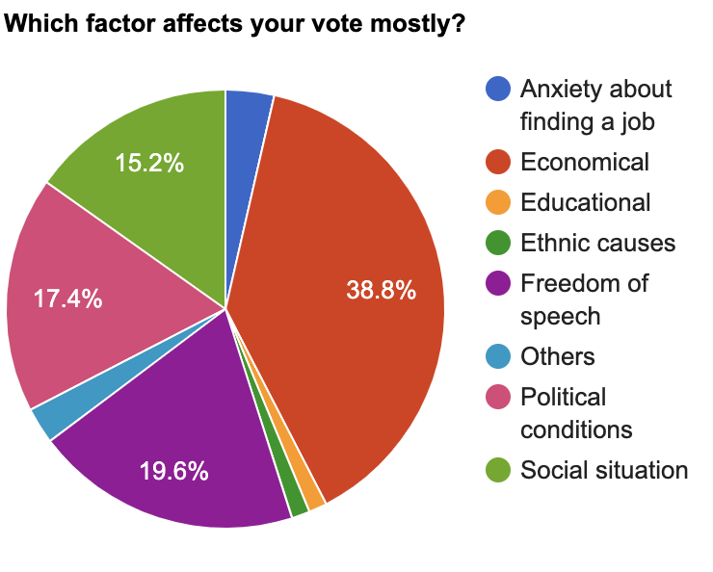

Figure

It can be seen in the pie chart on the right, economical situations affect the METU students' voting behavior most. Secondly, freedom of speech which gives us a idea about the situation of this topic in the country.

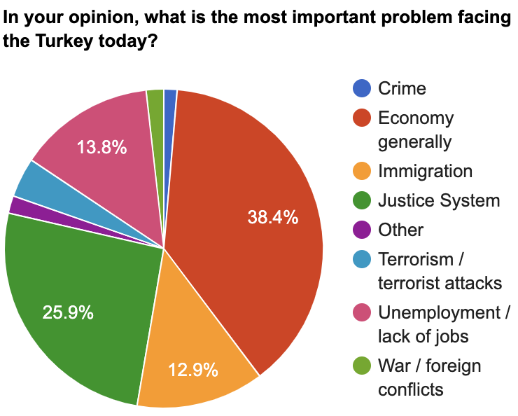

Figure

Again, we can say the economy is the prior problem in the country according to the pie chart on the right. Second most important problem for METU students in Turkey is the justice system.

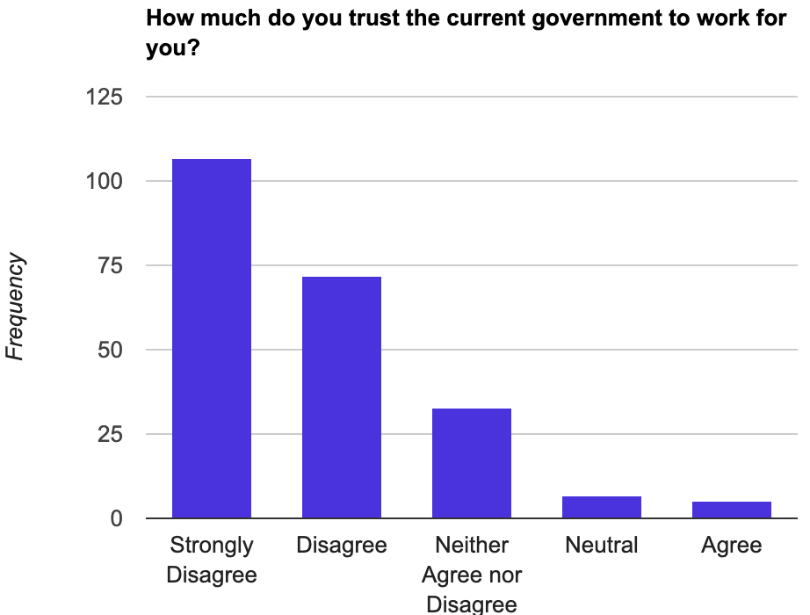

Figure

In this bar graph, it is asked to METU students if they trust their government briefly. Majority of them selected the options Strongly Disagree and Disagree with 107 and 72 people, respectively. It is obvious to say that they do not trust.

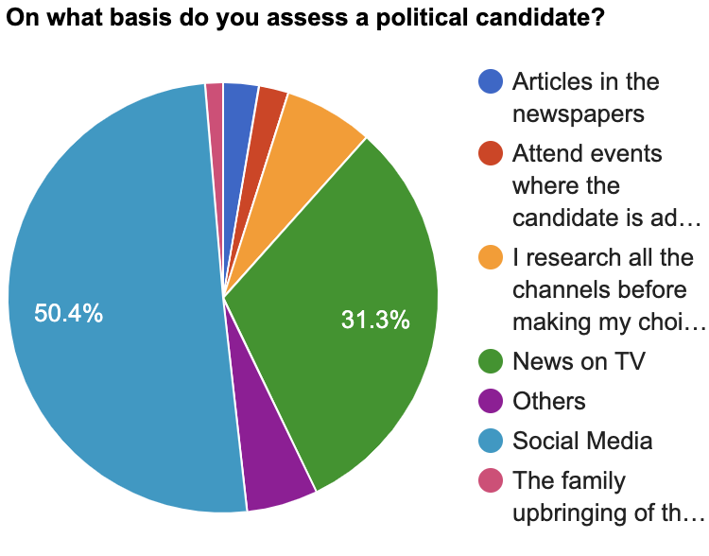

Figure

This pie chart shows not surprising results. METU students assess the political candidates mostly via social media. It can be easily expected because of the era that we live in. Second most tool to assess a political candidate is News on TV.

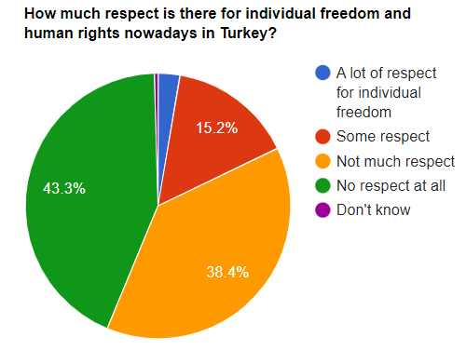

Figure

According to the pie chart, more than 80% of the respondents think that there is not much respect or no respect at all for human rights and individual freedoms in Turkey, while around 15% think that there is some respect for individual freedom and human rights nowadays in Turkey.

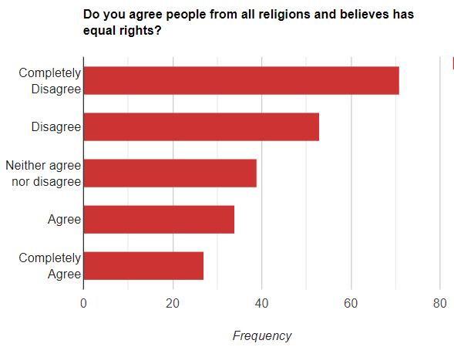

Figure

We presented 5 choices to the participants asking them: Do you agree people from all religions and believes has equal rights. The most chosen answer was "Completely Disagree". While almost a quarter of the answers are "Disagree".

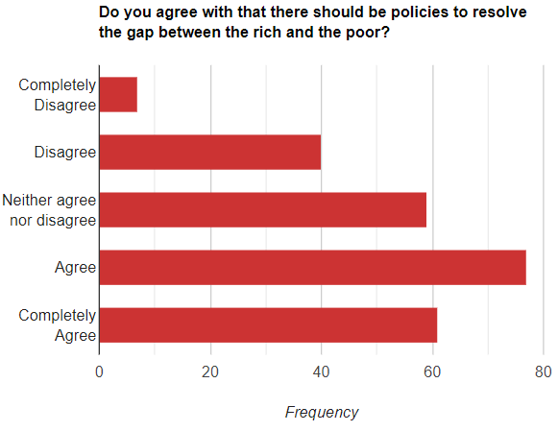It is seen that the majority of the participants in our survey think that income inequality between rich and poor should be resolved.

Figure

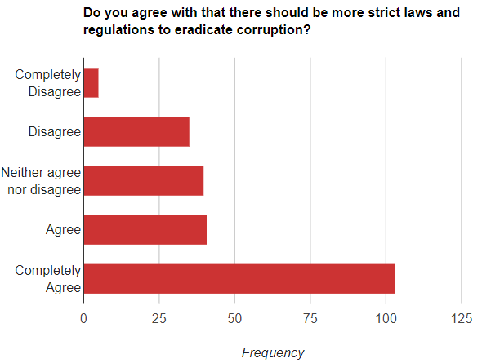In the chart, it can be seen that the majority of participants think that there should be more strict laws and regulations to eradicate corruption. The peak answer is "Completely Agree" with over 100 students.

Figure

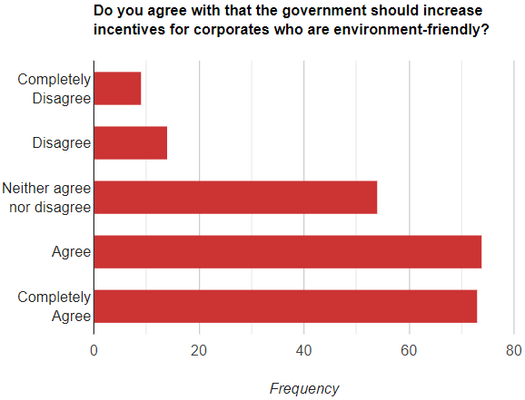

Figure

The bar chart shows the ratio of Agree and Completely Agree is almost the same, which is very high. So, Majority of the participants stated that the government should increase incentives for corporates who are environment friendly.

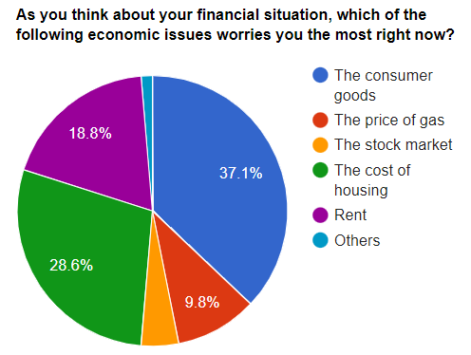

Figure

This pie chart indicates that consumer goods is the most challenging economic issues for the respondent, followed by house prices, rent and natural gas prices.

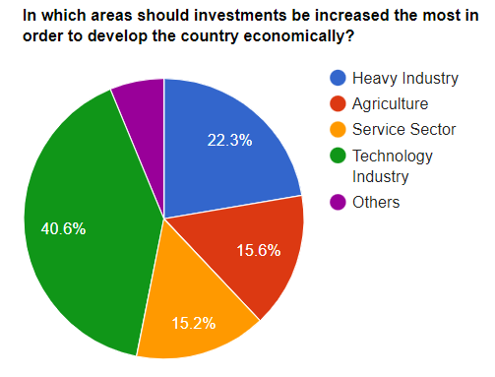

Figure

This pie-chart has been conducted from the results from the participants when they are asked in which areas should investments be increased the most in order to develop the country economically . While technology is the most critical sector according to 91 people, the number of those choosing the agriculture and service sector is very close to each other.

## Results and Findings

### Does the state of the nation's economy perception depend on student's income?

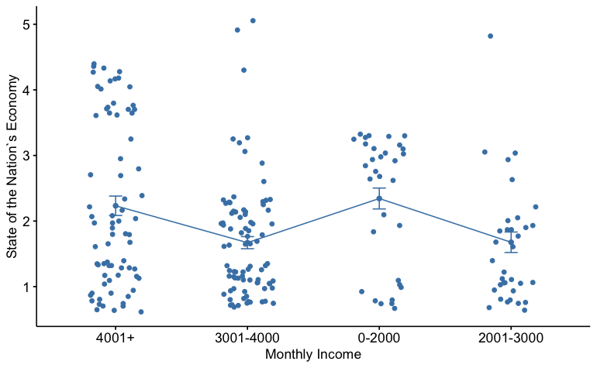

Figure

H0: The data is distributed normally.

H1: The data is not distributed normally.

Shapiro Wilk normality test For age ranges

|  |  |
| --- | --- |
| Shapiro-Wilk normality test | data: as.numeric(dt$X29..Would.you.describe.the.state.of.the.nation.s.economy.these.days.) |
| W = 0.811 | p-value = 8.906e-16 |

Table

P-value result from the Shapiro-Wilk normality tests are lower than 0.05, so the null hypothesis is rejected. The distributions of the variables are not normally distributed.

Since the data is not normally distributed, in order to see if there is a difference between the categorical variables, Kruskal-Wallis rank sum test will be used.

H0: μ1 =μ2=μ3=μ4=μ5

H1: At least one of them is different.

|  |  |  |
| --- | --- | --- |
| Kruskal Wallis Rank Sum Test | | |
| Data : Frequency of Disinfectant usage by age range | | |
| Chi-Squared : 55.349 | P- Value : 2.746e-11 | Degree of Freedom : 4 |

Table

Since the p-value is lower than 0.05, we can say that at least one the means is different.

To learn which mean is different than others, pairwise Wilcoxon test will be applied.

Pairwise comparisons using Wilcoxon rank sum test

|  |  |  |  |
| --- | --- | --- | --- |
| Monthly Income | 0-2000 | 2001-3000 | 3001-4000 |
| **2001-3000** | 0.00552 | --- | --- |
| **3001-4000** | 0.00077 | 0.90934 | --- |
| **4001+** | 0.72164 | 0.07423 | 0.02777 |

Table

According to wilccoxon test results , it is seen that the p-value (0.00552), 0-2000 and 2001-3000 income intervals have significant difference since 0.00552 is lower than 0.05. Also, there are significant difference between 0-2000 and 3001-4000 income interval also 3001-4000 and 4001+ income since p-values are 0.00077 and 0.02777 respectively which is also lower than 0.05.

### Is there any relationship between freedom of speech and Turkey citizens desire to apply to the EU?

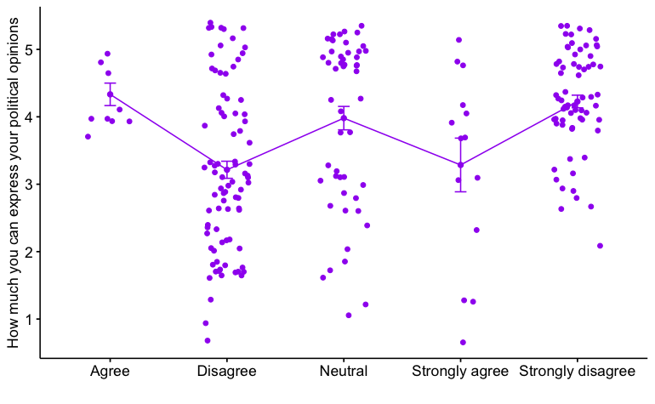

Figure

H0: The data is distributed normally.

H1: The data is not distributed normally.

|  |  |
| --- | --- |
| Shapiro-Wilk Normality Test | |
| p-value : 2.229e-15 | Degree of Freedom : 4 |

Table

The p-value is less than 0.05, the null hypothesis is rejected. Therefore the data is not normally distributed.

Since the data is not normally distributed, non-parametric tests are used. First, the Kruskal-Wallis test is used in order to understand if there is any significant difference between freedom of speech groups.

|  |  |  |
| --- | --- | --- |
| Kruskal Wallis Rank Sum Test | | |
| Chi-Squared : 33.419 | P- Value : 9.802e-07 | Degree of Freedom : 4 |

Table

From the output of the Kruskal-Wallis test, it is known that there is a significant difference between groups, but which pairs of groups are different is not known. It is possible to use the Pairwise Wilcoxon Rank Sum test to calculate pairwise comparisons between group levels with corrections for multiple testing.

|  |  |  |  |  |
| --- | --- | --- | --- | --- |
| Wilcoxon Rank Sum Test | | | | |
| **Freedom of Speech** | Agree | Disagree | Neutral | Strongly Agree |
| **Disagree** | 0.0156 | --- | --- |  |
| **Neutral** | 0.8589 | 0.0019 | --- |  |
| **Strongly Agree** | 0.1527 | 0.8589 | 0.1527 |  |
| **Strongly Disagree** | 0.8589 | 7.3e-07 | 0.8589 | 0.0603 |

Table

According to Wilcoxon Rank Sum Test results , it is seen that the p-values of Disagree - Agree, Neutral - Disagree, Strongly Disagree - Disagree and Strongly Disagree - Strongly Agree are lower than 0.05. Therefore, those groups which I mentioned in the previous sentence are significantly different.

### Is there any effect of religion to the people's perspective against their civil rights?

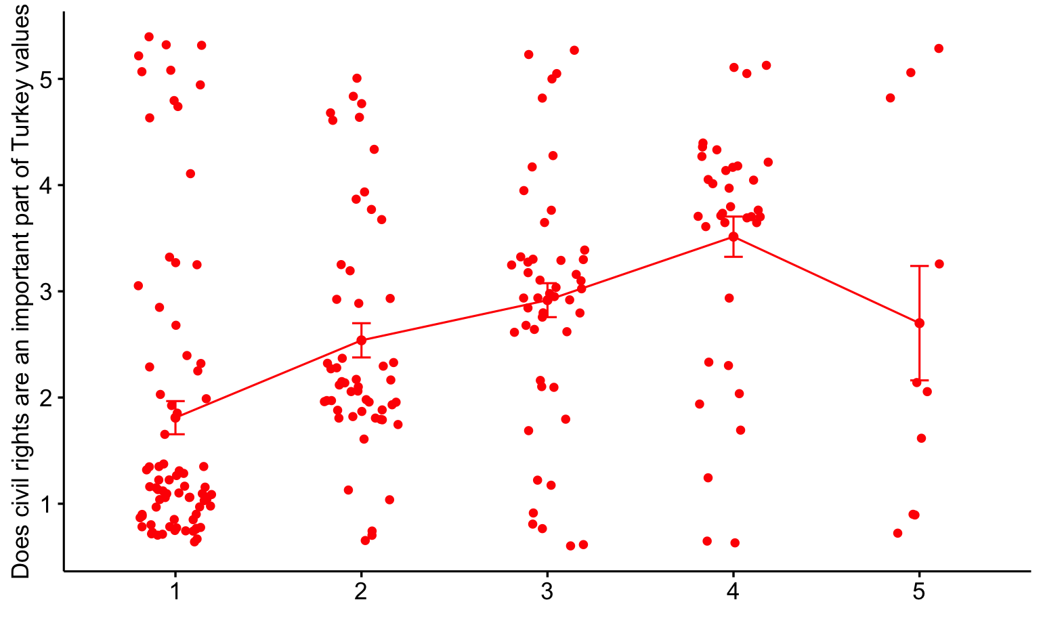

Figure

H0: The data is distributed normally.

H1: The data is not distributed normally.

|  |  |
| --- | --- |
| Shapiro-Wilk Normality Test | |
| p-value : 2.186e-13 | Degree of Freedom : 4 |

Table

The p-value is less than 0.05, the null hypothesis is rejected. Therefore the data is not normally distributed.

Since the data is not normally distributed, a non-parametric tests are used. First, the Kruskal-Wallis test is used in order to understand if there is any significant difference between opinions on civil rights groups.

|  |  |  |
| --- | --- | --- |
| Kruskal Wallis Rank Sum Test | | |
| Chi-Squared : 68.848 | P- Value : 3.973e-14 | Degree of Freedom : 4 |

Table

From the output of the Kruskal-Wallis test, it is known that there is a significant difference between groups, but which pairs of groups are different is not known. It is possible to use the Pairwise Wilcoxon Rank Sum test to calculate pairwise comparisons between group levels with corrections for multiple testing.

|  |  |  |  |  |
| --- | --- | --- | --- | --- |
| Wilcoxon Rank Sum Test | | | | |
| **Civil Rights** | 1 | 2 | 3 | 4 |
| **2** | 1.3e-06 | --- | --- | --- |
| **3** | 2.8e-07 | 0.0096 | --- | --- |
| **4** | 3.7e-11 | 2.6e-06 | 3.6e-05 | --- |
| **5** | 0.0014 | 0.8839 | 0..1964 | 0.0013 |

Table (1:Strongly Agree, 5:Strongly Disagree)

According to Wilcoxon Rank Sum Test results , it is seen that all the p-values are lower than 0.05 except 2-5 group. Therefore, all the groups except 2-5 group are significantly different.

## Conclusion

In this study, in order to collect data we directed specific questions to the participants about their voting behaviors. Online surveying by Google forms had been used. A total of 225 participants attended the survey. After collecting the answers, we conducted several analyzes to test the validity of the hypotheses. The data we have collected turned out to be both non-normal and non-linear. We tried to transform the independent variable, but we could not do it in any way. Thus, we were unable to conduct a linear model since our data was unable to meet any kind of necessary assumptions.

Several research questions have been conducted to be answered in order to make inferences about the METU students. After collecting the data and applying convenient tests such as Shapiro-Wilk test, Wilcoxon rank sum test, Kruskal-Wallis rank sum test in the study.

We are looking for if student's income has any effect on the state of the nation's economy perception. Since data is not normally distributed non-parametric tests are used which are Wilcoxon rank sum test, and Kruskal-Wallis rank sum test. As a result of these tests we find out there are significant differences on 0-2000 and 2001-3000 income intervals. Also, there are significant difference between 0-2000 and 3001-4000 income interval also 3001-4000 and 4001+ income.

We attempted to find that if there is any relationship between freedom of speech and Turkey citizens desire to apply EU. Since data is not normally distributed, non-parametric tests are used. First, Kruskal-Wallis test is used to understand if there is any significant difference between freedom of speech groups. By using Kruskal-Wallis we get that there is a significant difference between groups, but which pairs of groups are different is not known. Then, Pairwise Wilcoxon Rank Sum test is used to calculate pairwise comparisons between group levels with corrections for multiple testing. As a consequence of that test Disagree - Agree, Neutral - Disagree, Strongly Disagree - Disagree and Strongly Disagree - Strongly Agree groups are significantly different.

Finally, we attempted to figure out if there is any effect of religion to the people’s perspective against their civil rights. Shapiro-Wilk test is used, and we find that data is not normally distributed. Kruskal-Wallis test and Pairwise Wilcoxon Rank Sum test are also used. As a result of these tests we find out that there is a significant difference except the people who gave their response as agree and strongly disagree.

## References

(1) Biswas, A., Ingle, N., & Roy, M. (2014). Influence of social media on voting behavior. *Journal of Power, Politics & Governance*, *2*(2), 127-155.

(2) Dean, D. & Croft, R. (2009), Reason and Choice: A Conceptual Study of Consumer Decision Making and Electoral Behavior. Journal of Political Marketing, 8 (2), 130-146.

(3) Schoen, H., & Schumann, S. (2007). Personality traits, partisan attitudes, and voting behavior. Evidence from Germany. *Political psychology*, *28*(4), 471-498.

(4) Çinko, L. (2006), Seçmen Davranışları ile Ekonomik Performans Arasındaki İlişkilerin Teorik Temelleri ve Türkiye Üzerine Genel Bir Değerlendirme. Ankara Üniversitesi SBF Dergisi, 61 (1), 104-116.

(5) Goh, Y. M., Ubeynarayana, C. U., Wong, K. L. X., & Guo, B. H. (2018). Factors influencing unsafe behaviors: A supervised learning approach. *Accident Analysis & Prevention*, *118*, 77-85.